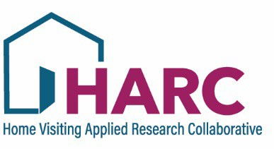
Home Visiting Applied Research Collaborative (HARC) - Study Proposal Form
Thank you for considering HARC’s practice-based research network as a venue for your study!
The HARC Council reviews and approves all proposed studies that are carried out with network members.
The purpose of this review is to ensure that the study is appropriate for a national home visiting research network, HARC’s PBRN, and that the study will be of interest to home visiting programs. To help with this, the HARC Council is reflective of HARC’s membership and is made up of representatives of the different home visiting groups. In addition to other researchers and/or evaluators, this includes program leadership and staff, model representatives, network leads, and families. Please ensure that the language you use is accessible to all members of these audiences.
If you have any questions about the process of submitting a proposal form or the use of Qualtrics, please email harc@hvresearch.org.

- Study Title: Click or tap here to enter text.

- Your Name: Click or tap here to enter text.

- Email: Click or tap here to enter text.

- For all other co-investigators, please provide the following information:
  - Name, Email and Institution: Click or tap here to enter text.
  - Name, Email and Institution: Click or tap here to enter text.
  - Name, Email and Institution: Click or tap here to enter text.
  - Name, Email and Institution: Click or tap here to enter text.

Proposed Study Design
- Background (750 words or less)
  - What are the primary research questions and/or study aims?
  - How will this study contribute to the broader field of home visiting research?
  - Does this proposed study activity fit within a larger study? If so, please describe.
Click or tap here to enter text.

- Methods (750 words or less)
  - What is the design of your study? (e.g., quantitative, qualitative, mixed-method)
  - What are your data collection methods? (e.g., survey, observation, direct assessment)
  - What specific measures do you propose using?
  - Who are the proposed participants and what is the proposed sample size (i.e., # of programs / home visitors / family participants)?
    - Do you plan to offer incentive payment for study participation?
  - Dissemination plan
    - HARC expects that one result of your proposed work will be a product that can be distributed, in a timely fashion, through the PBRN. This might be a brief or an infographic.
    - Please confirm that you understand this expectation
      - Yes
      - No
    - Do you have additional dissemination plans?
Click or tap here to enter text.

- Expected Participant Burden (400 words or less)
  - What are participants expected to do?
  - How much time will it take to collect the data from each participant?
Click or tap here to enter text.

- Expected Timeline
  - How long will it take to collect the data?
  - Describe the proposed timeline for the entire study.
  - Where are you in the process of receiving funding for this project?
  - Where are you in the process of human subjects review (IRB) for this study?
Click or tap here to enter text.

